HARPER'S MAGAZINE / SEPTEMBER 2014

CRITICISM

The miracle of Straight Life By Lili Anolik
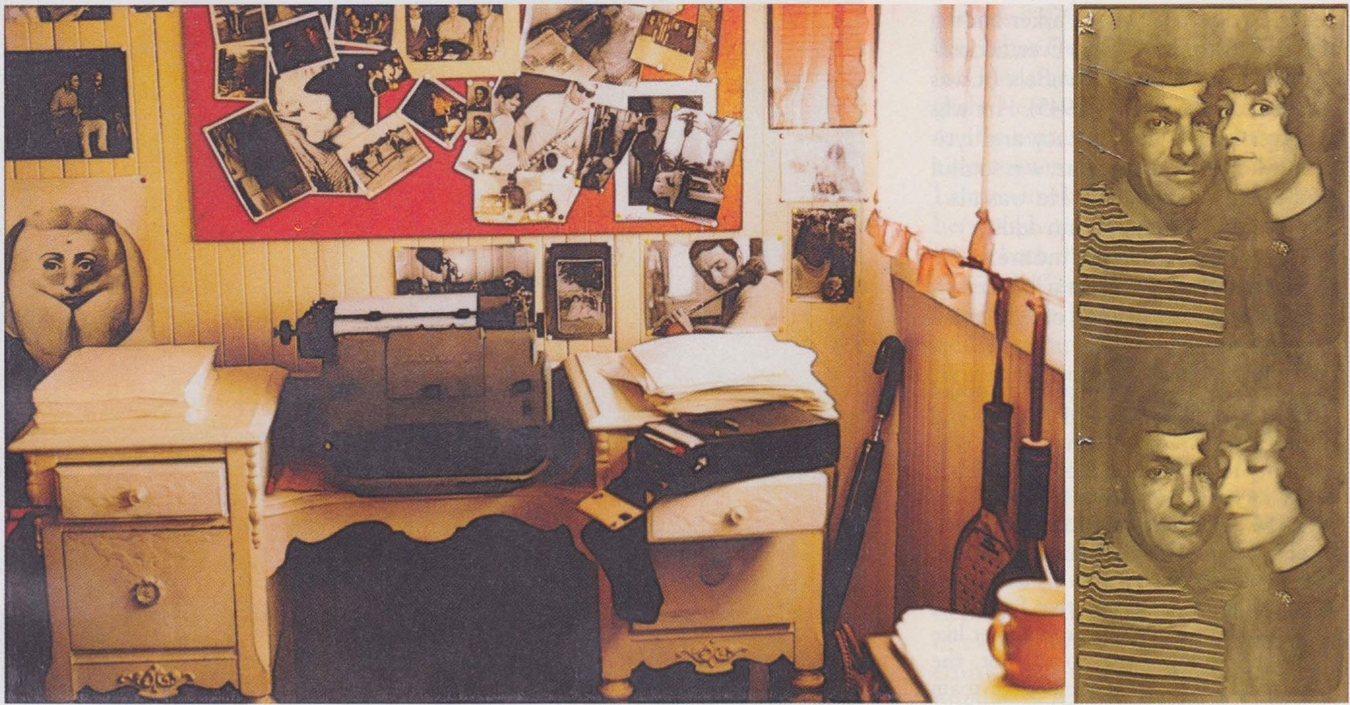

THE TALE OF THE TAPE

CRITICISM

This is an essay about an autobiography (Laurie Pepper's ART: Why I Stuck With a Junkie Jazz Man) that is in large part about the creation of another autobiography (Art Pepper's Straight Life), and I'm going to open with an excerpt from yet another autobiography (my own, title to come): I spent my entire ninth year reading Straight Life. I stole my bebop-fanatic father's copy because I liked
Lili Anolik's first novel , Dark Rooms, will be published next year by William Morrow

Lili Anolik's first novel, Dark Rooms, will be published next year by William Morrows.
Left: The desk at which Laurie Pepper wrote Straight Life, circa 1973
Right: Phoro-booth portraits of Art and Laurie Pepper, circa 1974.
All photographs © Laurie Pepper

the cover, how Art looked on it—that handsome face, those flashy clothes—and every night I took the book from its hiding place under my mattress. Each page was oh boy and oh wow. (His mom tried to abort him by doing what? He put his tongue where on that teenaged groupie? Pouring shoe glue on a rag and sniffing it-that was fun?) And as soon as I came to the end, I'd flip right back to the beginning. At some point I moved on to Sweet Valley High and The Baby-Sitters Club-books more in keeping with my identity as a fourth-grade girl with a canopy bed and a Schwinn tenspeed living in one of Boston's leafier suburbs. It wasn't until I was in my late twenties that Straight Life and I had a second run-in. I was helping my parents pack up their house when I found it on the dusty bottom shelf of a corner bookcase and slipped it into my bag instead of into a U-Haul box. I took it back to my apartment, where I stayed up the entire night rereading. It was oh boy and oh wow all over again.

Straight Life isn't widely known, but its fans are ardent. High-toned, too. Former U.S. poet laureate Robert Pinsky compared passages in it to Dickens, Joyce, and Dostoyevsky. The film director Mike Figgis, who attempted to adapt it in the late 1990s after his Leaving Las Vegas earned a best-picture nomination—"[Art's] widow and I did not see eye to eye" was his dry assessment of why the adaptation never came to be-placed it among his "six best books." In the London Review of Books, Terry Castle called it, simply, "the best book [she'd] ever read."

These are serious people, not given to hyperbole. And as their responses suggest, Straight Life is something more than the typical penthouse-highs-gutter-lows memoir of a successful musician, though Art Pepper was that: second only to Charlie Parker among the Best Alto Sax Players Ever, according to the readers of DownBeat (it was a squeaker, 957 votes to 945). Art was a player of unusual delicacy and lyricism who, at the same time, was soulful and could really swing. He was also, and every bit as majorly, an addict.

Here he is on the moment he found his Holy Grail in a bathroom on the fourteenth floor of Chicago's Croyden Hotel:

I looked at the few remaining lines of heroin and I took the dollar bill and horned the rest of them down. I said, "This is it. This is the only answer for me. If this is what it takes, then this is what I'm going to do, whatever dues I have to pay ... " And I knew that I would get busted and I knew that I would go to prison and that I wouldn't be weak; I wouldn't be an informer like all the phonies, the no-account, the non-real, the zero people that roam around, the scum that slither out from under rocks, the people that destroyed music, that destroyed this country, that destroyed the world ... I realized that from that moment on I would be, if you want to use the word, a junkie. That's the word they used. That's the word they still use. That is what I became at that moment. That's what I practiced; and that's what I still am. And what I will die as-a junkie.

He's turning the stereotype of the craven, sniveling addict on its head: heroin isn't the weakness he submits to; it's the passion he revels in. And while he realizes that if he follows this passion-and at no point does he stop following it, not truly; he is at his cleanest only clean-ish-there will certainly be moments in which he's down and out. He vows he'll never be less than stand-up. And he never is. Unlike Chet Baker, long rumored to have been a police informant to avoid jail time, he doesn't rat or squeal, doesn't violate his code or principles, his sense of honor, even though he pays the price, again and again, spending many of the best years of his life rotting away in a five- by nine-foot cell.

The book is filled with such passages. But as you're reading along-flying along, really-getting higher and higher listening to Art recount his hustles and scuffles, fuck-ups and misadventures, there's this question tugging at you, pulling you back down to earth: How did that guy write this book? Clearly Art has the intelligence and intensity and chops. The energy, too. His energy, though, is of the manic sort. It's not the sustained, plodding, grind-it-out-till-the-bitter-end kind you need to pro- duce a memoir of nearly 500 small-print pages. Enter Laurie Pepper, at the time Laurie Miller.

She and Art met squalid in the summer of '69. Art was forty-four and fresh out of San Quentin, where he'd done a five-year stretch after getting busted with a condom full of dope. He was a wreck and a ruin, not only a junkie but a juicehead. Unemployable as a musician, he'd taken to driving getaway cars in stickups for chump change to support his habit. Once a dead ringer for Marcello Mastroianni, he'd become a death's-head, sunken-eyed and hollow-cheeked, with a body covered in track marks and freaky prison tats: a skull smoking an opium pipe; a girl doing the limbo; a woman naked, squatting; and, freakiest of all, Charles Schulz's Snoopy. Heroin and liquor had done a number on him. There was also the ruptured spleen, the herniated belly. He was sick in other ways as well, a voyeur and masher, a compulsive masturbator and occasional rapist. The wife he'd been wild about had left him for a drummer. The wife he could barely stand had snitched him out to the cops, then died. His girlfriend had dumped him at his mother's door, and his mother had refused to open it. He was out of work, out of bread, out of love, out of luck. Also, out of drugs. The last place he wanted to be was some hippie-dippy institution like Synanon, Santa Monica's rehab-commune-by-the-sea, except at that point it was pretty much Synanon or the grave.

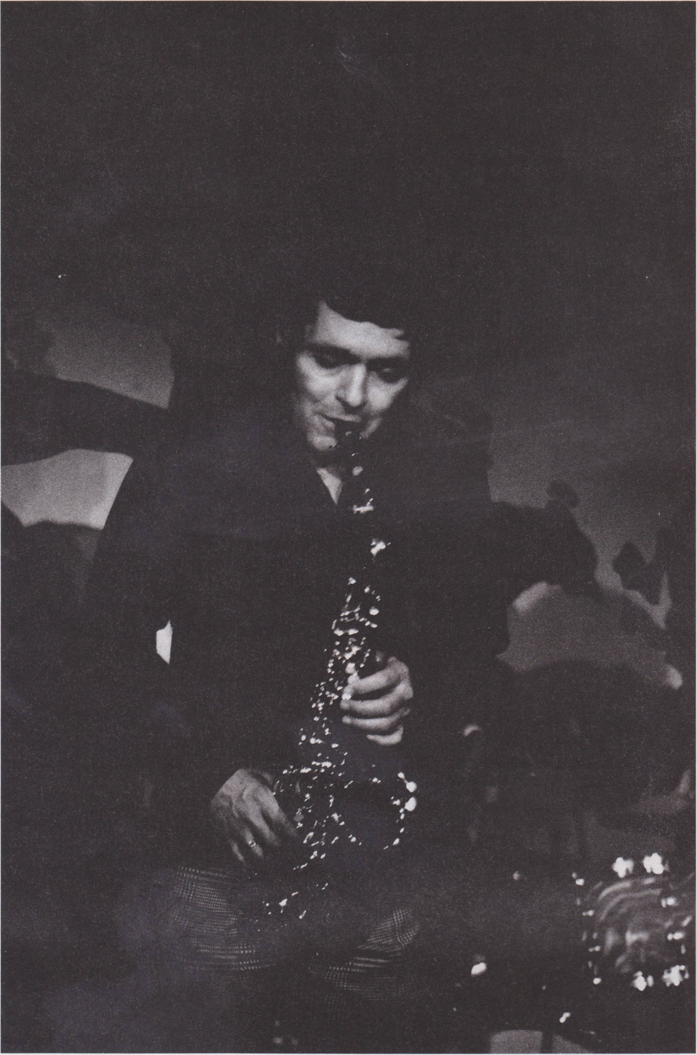
Art Pepper performing at Donte's in Los Angeles, circa 1976

Laurie wasn't in quite as bad shape when she walked
into Synanon. (Art's tough to beat when it comes to bottoming out.) Pretty bad, though. She was twenty-eight, twice-divorced, and she'd just lost custody of her young daughter. She'd been working in Hollywood as a music photographer, shooting Joni Mitchell and Leonard Cohen, among others. On learning that a friend had stolen her cash and her pills, she'd sealed up the house, turned on the gas, and arranged her body on the floor. She got bored, though, before she got dead. And after throwing open all the windows, she'd fished the loose change from her purse, and headed to the local Cap 'n' Cork for a bottle of Chablis—"I drew the line at Muscatel"—admiring the fragrance of the tiny white blossoms on the trees as she trotted along in her snakeskin heels.

She'd been at Synanon for nine months when Art's mom's husband, Merle, borrowed a truck from the gas station where he worked and drove Art out to Santa Monica. Most women wouldn't have looked at Art-rolling around on one of the kicking couches, puking into a trash can, snarling at the other residents, non-addicts in the main, middle-class types with coping issues ("lifestylers" in Synanon parlance; "wide-eyed, stupid little broads and idiotic assholes" in Art parlance) who'd come to peer at him-and seen Mr. Right. But to Laurie, Art looked better than Mr. Right. He looked like Mr. Cool. No, he looked even better than that. He looked like the Real Thing.

Soon Art would be off that couch and looking right back at Laurie. The two would, in more or less this order: embark on an affair, fall deeply in love, leave Synanon, move in together, get married, revivify Art's musical career, publish Straight Life. Which brings us back to the original question: How did that guy write this book? The answer, as you'll discover in Laurie's considerably more streamlined memoir, is that he didn't. Not surprising. Very surprising, however, is that she didn't either. And most surprising of all is who did: no one.

Before I explain that, though, an aside that's really to the point. I realize that I'm supposed to be giving you an assessment of ART: Why I Stuck With a Junkie Jazz Man and instead I'm chewing your ear off about Straight Life. So my verdict doesn't get lost in the shuffle, I'll say right now that ART: Why I Stuck with a Junkie Jazz Man can be read as a stand-alone book, and an excellent one-poignant, beautifully observed, sharply, triumphantly funny. It also, however, and perhaps most illuminatingly, can be read as a companion to Straight Life. It's part of the same emotional setting, and it dwells in serious and loving detail on Straight Life's creation. In fact, in many ways, it serves as an expansion of the afterword Laurie wrote for Straight Life's 1994 Da Capo edition, an afterword so beguilngly understated it left you wanting more.

Laurie grew up among artists. Her mother was a dancer with Martha Graham. Her father, Dick LaPan, formerly Lapinsky, a peculiar, Zelig-like figure, was a writer. His accomplishments are hazy-a book of short stories published in Spanish only, an autobiography floating somewhere out there-yet he manages to pop up in the corners of some very happening frames: there he is at San Simeon, asking William Randolph Hearst and Marion Davies to pass the salt; at the house of Salka Viertel, the screenwriter who ran a celebrated salon for German ex pats in Los Angeles; in Christopher Isherwood's diaries, making several memorable cameos ("Who should turn up on the beach but Dick LaPan. He lives down in Guadalajara now and teaches English. He says he much prefers Mexico to the States; people are kinder. He even tolerates the Catholic Church"). Laurie's uncle Sol, more of a father to her than her actual father, was first violin for both the L.A. Philharmonic and the 20th Century Fox Orchestra. Sol and his wife, Mae, kept ultra-fast, ultra-exalted company. Stravinsky was godfather to their eldest daughter. Jelly Roll Morton and Stuff Smith, Arnold Schoenberg and Bernard Herrmann, were regular dinner guests.

More than anything, Laurie wanted to go into the family business, be an artist herself. She seemed to experience a powerful need to express herself creatively yet lacked a means of expression. Part of her difficulty, I think, lay in the abnormally high number of things she could do well—playwriting, acting, poetry, singing, and, of course, photography. You listen to her story and you start to notice a pattern: she becomes infatuated with a particular discipline, throws herself into it, achieves some success, at which point the crisis of confidence hits, followed by, in short order, a freak-out, a cut-and-run, and then a mad scramble for the next thing, the next enthusiasm. Take, for example, her foray into chanteusedom. In her words, "[I] thought I might become a singer ... I liked the funky glamour. I liked the role ... I was given an entrance exam [at Westlake College of Music] ... I did quite well." So far, so promising. Not for long:

"I knew I wasn't good enough. My voice lacked strength, my time was uncertain." And she's out the door: "It seemed to me then that my options were limited. I could lead the ... loveless life of an unsuccessful singer, or I could make a cozy home with Gary [her squeeze of the moment, one she had ho-hum feelings about] who would cherish and adore me." And so another career ended. (Soon, her relationship with Gary did, too. She was right not to be enthused. He turned out to be not just a wife-beater but a cat-torturer.)

I suspect Laurie's background-the household she was raised in, so intensely creative and accomplished—undid her as much as anything else. Surrounded by the people she was surrounded by, she had ideals and standards, exacting and fastidious ones, and they fouled her up, made her uptight and self-conscious at the exact moments she needed to be loose and uninhibited, to let rip. Fledgling efforts are, almost without exception, sloppy. But she couldn't tolerate slop, not from herself, and so making those early attempts became impossible. And if that wasn't enough, she "despised [herself] for [her] inadequate suffering." She aspired to be "marvelous and real, like Billie," as in Holiday, who grew up black, fatherless, motherless most of the time, a prostitute at thirteen, a jailbird at fourteen. And yet Laurie was born into the educated bohemian Jewish middle class. So by her reckoning, she'd flopped in utero. It was over for her before it began.

As much as a white guy unable to carry a tune can be Billie Holiday, Art Pepper was Billie Holiday. His family was Southern California underclass-white trash, to spit it out-his dad a merchant seaman and his mom a fifteen-year-old runaway who got pregnant after a one-night stand and did whatever she could to miscarry. His childhood was filled with physical and emotional brutality. Still, Art had it easier than Laurie in one respect: he never had to struggle to find his ax, was practically born swinging it. He started on the clarinet at nine, switched to alto at twelve, was working in jazz clubs up and down Central Avenue at fourteen, playing with the likes of Dexter Gordon, Charles Mingus, and Lee Young. He was a natural, a runaway talent.

Here's the really wild thing, though: it wasn't the music Art made with his horn that fired Laurie's imagination. It was the music he made with his mouth-his patter-that did. At Synanon, established lovebirds were allowed to engage in mating-ritual-type activity by appointment. After Art and Laurie did their thing, they'd have time left over, and they'd kill it the way most couples do: with conversation. Pillow talk, basically. Art's pillow talk, Laurie came to believe, was of such a high order that it wasn't pillow talk at all; it was oral history. Or could be turned into such with a little effort. In her own words:

I'd read The Children of Sanchez-twice. It was a book by the social anthropologist Oscar Lewis, the biography of a Mexican family ... [He) put the family's history together in a way that made the whole more powerful than any memoir or novel I had ever read. I'd been thinking that's how Art could tell his story. He could tell his remarkable life in his own extraordinary language through me, and I would interview his friends and family, too ... Lewis found his vehicle in the Sanchez family. Art Pepper could be mine. So at that time I thought I might have finally found a way to satisfy myself, to justify my existence. I would produce something that I could believe was important, and because Art was so charismatic, and his story so sordid, scary, so romantic, and sexy, the world would agree with me.

Laurie was defining her terms very carefully here. What she was doing, I think, was trying to un-psych herself out. If she could fly below the radar, keep from attracting the attention of her ego, maybe she could slip one past it. That's why she was choosing The Children of Sanchez as her model. (Now, I've read The Children of Sanchez. It's perfectly fine, but it's not Notes from Underground or The Trial, both of which bear a more-than-passing resemblance to Art's tale.) Once she'd established the modest dimensions of her task, made sure she had no masters breathing down her neck, she could just roll up her sleeves and get to it.
Another thing Laurie had going for her: her faith in Art, unlike her faith in herself, was unwavering. He was an authentic artist, an American original. The moment she got together with Art, her spinning wheels found purchase. Suddenly, she was surging forward. Suddenly, too, her life made perfect retrospective sense; her early failures weren't failures at all, but training, preparation-the singing lessons, the studies in folklore (her major at Berkeley, where she'd dropped out after sophomore year), the plays and poems she'd written.
This was a joint effort: Art's voice and story, Laurie's craft. She describes their collaboration thus:

Art tended to tell an anecdote a little differently every time he told it ... So I got him to tell me some of the same stories over and even over again. Then I'd take my transcriptions of his different versions ... pick out the best parts, cut redundancies and excess, clarify ambiguities by changing words and/or syntax, make or ask Art to make transitional sentences and then read it all back into the tape recorder, making sure I could 'talk' the changed material with ease and that it reflected Art's speech patterns and rhythms. I'd make him listen. I'd ask him, 'Does this sound like you?' After I typed out the edited story ... I would have to decide whether it really belonged in the book, and, if it did, where it belonged.

See what I mean? No one wrote Straight Life. Art talked the book, Laurie edited the book, and through some peculiar form of alchemy or magic or gestation (the process has more than a little in common with baby making, is mysterious in the same way, miraculous in the same way, two parts adding up to a greater whole), they both created the book.

Upon the book's publication, Art got a lot of attention, saw a resurgence of interest in his music and in him. Though Laurie's name was on the cover, right next to his, her efforts were low-balled, condescended to, or overlooked altogether. The New Yorker jazz critic Whitney Balliett was particularly egregious in this last respect, mentioning her not once in his entire review. And the great Studs Terkel—Studs, an oral historian himself!—didn't throw a single question Laurie's way during his joint interview of the couple. Gary Giddins was the rare exception, declaring in the Village Voice that "[Laurie] is undoubtedly responsible for the book's shape and much of its literary texture, and her efforts can hardly be overpraised." When I recently asked Gary how he guessed at the extent of her involvement, he said, "By the time Straight Life came out I'd met Art. You spend five minutes with Art you know Art couldn't have written that book." And Art knew that Art couldn't have written that book. His inscription to Laurie read, "You have done what people have been trying to do & will try to do 'til this life is replaced by a much more beautiful one; Create a MASTERPIECE!!"

Most disturbingly of all, Laurie reveals in her memoir that she very nearly gave herself the shaft: At the last minute, she tried to have her name removed from the cover. Fortunately, Art and their editor Ken Stuart balked. Laurie explains:

Part of [my ambivalence), I know, comes from being a girl who grew up in the 1950s absorbing the knowledge that girls weren't supposed to be showoffs. One reward for staying in the background was we wouldn't have to prove ourselves continually like boys did. And we would be admired: the movies showed us that the quiet good girls got the guys .... Plus, our coyness and lack of competitiveness meant we weren't so often criticized. I feared criticism like feared death and didn't try for praise in case I got its opposite.

Laurie is an uncommonly honest person. (Same as Art, she seems incapable of telling a self-protective lie.) An uncommonly perceptive one, too, and it's hard to make an observation about her that she hasn't made about herself. But I believe she was misdiagnosing her ambivalence. Or, rather, incompletely diagnosing it. In The Journalist and the Murderer, Janet Malcolm's classic study of the bad faith at the heart of the relationship between non-fiction writers and their very real subjects, Malcolm notes "the dire theme of Promethean theft, of transgression in the service of creativity, of stealing as the foundation of making." And there is some of that thievery going on here. Straight Life wouldn't exist if Laurie hadn't wrested from Art his story and language:

[Art) kept putting me off ... During the next months we began to tape every few days. I became compulsive about it. Art started resisting ... Sometimes he'd get so loaded beforehand, he'd nod out in mid-sentence. I'd kick his foot and he'd start up again just like the Doormouse in Alice. Sometimes I bribed him with candy and ice cream (he was a lazy person, and I was willing to walk to the store). I'd beg him to talk for 15 minutes and sometimes keep him going for an hour.

And then there's her reaction to Art getting led away in handcuffs after a period of increasingly out-ofcontrol behavior that ended with him smashing up his car while high:

He came out of each weekend incarceration a little more depressed. He didn't think, anymore, about drugs. He became as docile as I might ever have wished him to be. He was practically catatonic ... circumstances had finally rendered him ready to accept my leadership.

Laurie's pursuit was high-minded, but her method was the opposite. There was a Scarlett O'Hara whatever-it-takes ruthlessness about her when it came to the book. She was willing to lie, steal, cheat, or kill to get the job done. I love that about her, how dauntless she was, how game. She wasn't fussy. She wasn't squeamish.

The squeamishness came later. It bothered her-still bothers her, I think-that Straight Life wasn't an immaculate conception. (Compliment Laurie on it and she'll be gracious, say thank you, but she'll also develop a sudden fascination with the tabletop or the laces of her shoes, her sense of discomfort palpable, like she's accepting praise for the work of another.) She couldn't generate purely from herself. For Straight Life to be born she needed to get down and dirty, needed Art and Art's contribution. Does that make the book any less hers? No more, in my opinion, than it makes her daughter Maggie any less her daughter because for Maggie to be born she needed to get down and dirty with Maggie's father, Barrett.

If I may compare apples and oranges for a moment, Straight Life is every bit as good as Art's very best album. In her memoir, Laurie writes, "I heard Art say once to somebody that you only need enough technique to say what you have to say ... [H]e believed passion and desire could pull him past his own physical limitations." That's what happened with Laurie and Straight Life. The passion and desire she felt for Art, both uppercase and lower, allowed her to move beyond her own boundaries and restrictions, break free, to transcend herself. On second thought, though, maybe they're not apples and oranges because I see Laurie as the literary equivalent of a jazz musician. She does to Art what Art does to a standard like "How High the Moon" or "Stella by Starlight." She absorbs the chords and melody he provides and then riffs on them, uses them as take-off points.

And if Laurie was predatory in her relationship with Art, she was even more nurturing. Art said that when he entered Synanon he was "finished with life." Laurie brought him back to it. She kept him healthy, grinding up organic carrots several times a day for fresh juice, a remedy for the arthritis crippling his hands. She kept him out of the clutches of dealers, threatening a Vietnam vet with a bullet to his brain if he didn't stop supplying Art with angel dust. She kept him engaged and employed, writing letters on his behalf to colleges and universities with jazz bands to offer his services for clinics. She did all this because she loved him as a person and as a talent. When she talks about the experience of listening to him play, her language becomes downright reverent: "Art put his horn to his lips and played liked an angel ... In my years with [him], I saw it happen many times. It never failed to stun me. He stumbled to the bandstand, and then God took over revealing where the gift was always from." And if Art spent his early years trying to return that gift, get it off his hands, hide out from it in addiction and prison and hassles with women, he spent his later years-the Laurie years-making the most of it. "Pepper's sudden reappearance in 1975 had been something of a second coming in musical circles," Giddins wrote. "For the next seven years, his frequent recordings and tours ... transformed him from a gifted altoist who had made a string of semi-classic albums in the Fifties to a touchstone for the very aesthetics of jazz music." So Art's comeback was less a comeback than it was an overtaking. Because of the loving care Laurie provided, the stability, the support, the discipline, old Art was able to leave young Art in the dust.

Alone, Art and Laurie were lost; together they were found, each achieving self-definition by merging. (Really, the two give codependency a good name. Second acts, too. They're the anti-Scott and Zelda.) In so many ways theirs is the ideal of a marriage, a counterbalance of strengths and weaknesses, hard and soft, prose and poetry, call and response. And Straight Life is the product of this harmonious union. It takes after the mother as well as the father, got the best of both. •

